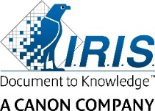
IRIS launches its new
IRIScan™ Desk range onto the market:
smart, versatile scanning for professionals
Louvain-la-Neuve - Belgium, xx June 2019 - IRIS (Canon Group), a leader in information management, announces the market launch of a new range of scanners, including two new products: IRIScan™ Desk 5 and IRIScan™ Desk 5 Pro. This technology, developed thanks to the brand's investment in R&D, combines the functions of a high-resolution camera and an ultra-fast scanner.
For use by businesses in the field of tourism (hotels, apartment rentals, etc.), public services (town halls, hospitals, libraries, etc.), financial institutions (banking and insurance), specialist companies (telecom operators, etc.) or, more generally, any professional needing to retrieve and/or extract data. This camera scanner can speed up data collection by shortening the process of inputting official information, whilst preventing errors.
 |  | IRIScan™ Desk 5, stylish and ergonomic, the new advantage for professionals
Thanks to this new camera scanner, you can scan any type of document or book: contracts, invoices, receipts, plans, newspapers, and magazines, without the need to cut them and damage them (up to A4)! Bound or spiral-bound documents are easy to scan. Simply enable automatic page change detection and convert the whole document into a Word, Excel, or PDF file.
It is now possible to scan an entire paperback book by placing it under the camera and holding its edges. The page will be flattened, and your fingers will be detected and erased from the final image.
Finally, IRIScan™ Desk 5 can also create video formats thanks to its function that records the progress of an operation or demonstration. A very practical function for recording web tutorials, unboxings, or live screenings for online courses.
IRIScan™ Desk 5 Pro, the technological advantage that combines simplicity, performance, and time saving.
In addition to the capabilities of its little sister, IRIScan™ Desk 5 Pro can handle bigger documents (up to A3), and is intended for architects’ offices, notaries, hotels, schools, and the security sector. It can also scan official documents such as passports and ID cards with just one click (using an optional dedicated IRISPowerscan™ solution). Amongst other things, it allows hotels to satisfy their legal requirement to send a daily guest list to the local authorities. Finally, it can also scan business cards or driving licences. Just place the document under the device, in any orientation. Thanks to its integrated multilingual OCR technology, the data, once scanned, are automatically extracted without any manual intervention.  It can also recognise 1D to 2D barcodes, as well as QR codes, and export the results to an Excel or text file. |  |  | 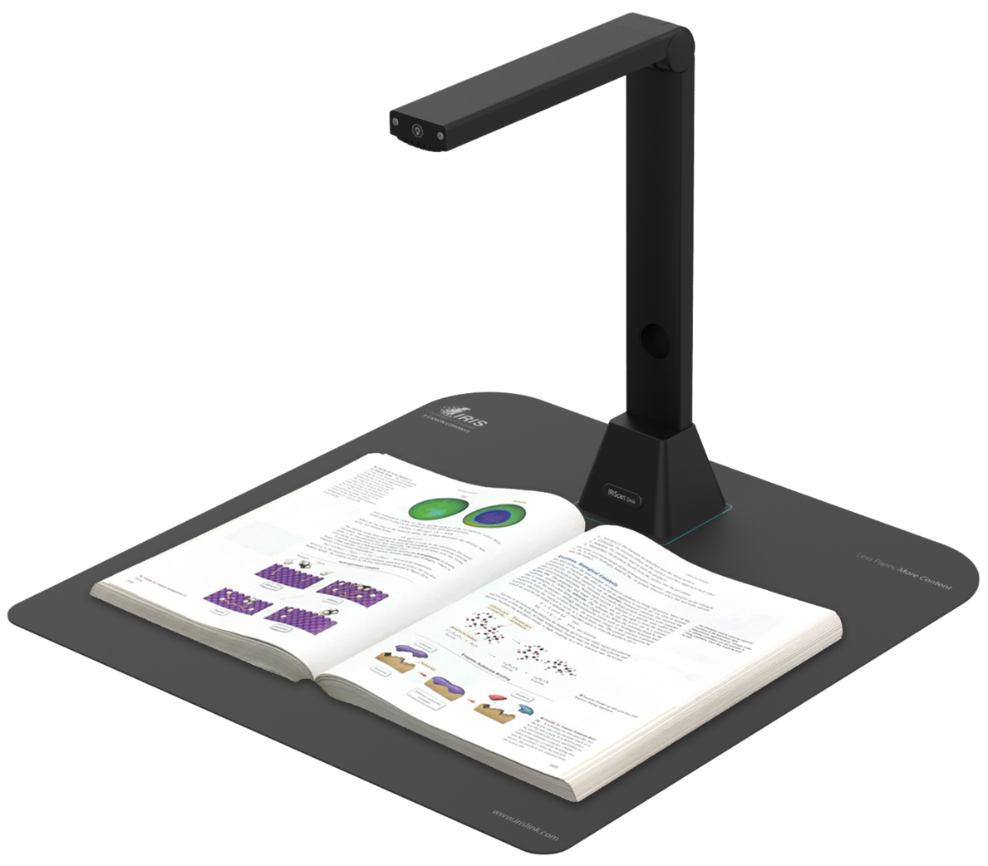
Market launch in June 2019
 | IRIScan™ Desk 5, with its 8-megapixel camera, will have a recommended retail price of €199. IRIScan™ Desk 5 Pro, with its 12-megapixel camera, will handle up to A3 format documents and will have a recommended retail price of €299.
About IRIS
IRIS (Canon Group) is a leader in Information Management and offers a complete range of innovative technological solutions, products, and services. For nearly 30 years, IRIS experts have successfully supported customers all over the world, helping them overcome their main business challenges through the use of scanning and capture solutions, EDM, and knowledge management and digital transformation. IRIS assists its customers by providing consulting services, making its research and development expertise and its technology available to them.
The company's head office is located in Louvain-la-Neuve (Belgium), serving 30 million consumers. Its customers include government organisations (Ministries, European Union), multinationals, local companies, and SOHO users. As a technology company, IRIS has built a vast ecosystem of innovation, technology, and distribution partners. IRIS is a centre of excellence within the Canon Group.
Follow us:
LinkedIn - Twitter - Youtube - www.irislink.com
IRIS Product Catalogue
Marketing Sales Toolkit
Press contact
Clémence Figenwald – clemence.figenwald@iriscorporate.com - +33 6 14 28 23 56

